Loan Portfolio Credit Risk Analysis
Analyst’s Technical Report
By: Uloh C. Armstrong
Portfolio risk profile · drivers of default · high-risk segments · default prediction · credit-risk monitoring

Item | Detail
Primary tool | Microsoft Excel (workbook: Credit_Risk_Monitoring_Tool.xlsx)
Supporting tools | Python (pandas, statsmodels, scikit-learn) for cleaning rules and model-parameter estimation; Power Query M script for Excel-native refresh
Data | credit_risk_dataset.csv — 32,581 raw loans, 32,411 after cleaning
Report date | November 2026

Contents
1. Project overview
2. Business objectives and analytical questions
3. Dataset overview
4. Data quality assessment
5. Data cleaning and preparation
6. Tool-specific execution (Excel)
7. Objective-by-objective analysis
8. Key findings
9. Business recommendations
10. Technical and analytical limitations
11. Validation and quality assurance
12. Lessons and professional competencies demonstrated
13. Conclusion
Appendix A. Logistic regression coefficients
Appendix B. Decision tree rules

1. Project overview

1.1 Project title
Loan Portfolio Credit Risk Analysis & Default Monitoring Tool - an Excel-based analytical solution for a lending institution.

1.2 Business scenario
A lending institution has asked its data team to explain the risk in its loan book. It holds historical loan applications, borrower profiles and repayment outcomes. Management wants to understand the portfolio, identify the characteristics that go with default, and improve its ability to monitor credit risk.

1.3 Business problem
About one in five loans in the book defaulted (21.9%), but the institution had no structured view of where that risk sits. Credit decisions appear to rely on the assigned loan grade, and management could not say which borrower and loan characteristics drive default, which segments are unacceptably risky, or how well default could be anticipated at application. Without that, limits and approval rules cannot be targeted, and risk cannot be monitored as the book changes.

1.4 Purpose of the analysis
To give management (credit risk, lending policy and portfolio management) an evidence base and a practical tool to: (1) measure the portfolio’s risk profile; (2) identify and quantify default drivers; (3) locate high-risk segments; (4) estimate each borrower’s probability of default (PD); and (5) monitor risk going forward.

1.5 Scope
- In scope: all 32,581 supplied records; data assessment and cleaning; descriptive, inferential and segment analysis; two predictive models with hold-out validation; an interactive Excel monitoring workbook; recommendations and monitoring indicators.
- Out of scope (data not available): trends over time, vintage and roll-rate analysis, loss given default and expected loss, profitability, approval/decline decisions (reject inference), and out-of-time model validation.

1.6 Tool used
Microsoft Excel is the primary tool. Every KPI, summary table, statistical test, segment ranking, model score, evaluation metric, dashboard element and finding in the workbook is a live Excel formula that recalculates when the data or settings change.
Two steps used Python as a supporting tool, because Excel cannot do them natively without add-ins: (1) applying the documented cleaning rules reproducibly to 32,581 records (an equivalent Power Query script is provided), and (2) estimating the model parameters - maximum-likelihood logistic regression coefficients and a CART decision tree. Those parameters were then written into the workbook and implemented, scored and evaluated in Excel. The logistic log-likelihood is recomputed in Excel so the coefficients can be re-verified with Solver.

2. Business objectives and analytical questions

2.1 Objectives
- Assess the overall performance and risk profile of the loan portfolio.
- Identify customer and loan characteristics associated with default.
- Evaluate how loan grades and interest rates relate to default rates.
- Identify high-risk loan segments.
- Develop a predictive model to estimate the likelihood of loan default.
- Translate the findings into recommendations for credit risk monitoring.

2.2 Analytical questions
- Portfolio performance: How many loans are represented? What percentage of borrowers defaulted? What is the total value of loans issued? What is the distribution across credit grades? Which loan purposes account for the largest share of lending?
- Risk segmentation: Which grades have the highest default rates? Is income associated with default? How does loan-to-income relate to default? Do shorter employment histories default differently? How does default vary across purposes and home-ownership categories? Is there a relationship between interest rates and default?
- Predictive analysis: Can we estimate a borrower’s probability of default? Which variables are most useful? How does logistic regression compare with a tree-based model? What proportion of actual defaults can the model identify?

2.3 Objective-to-analysis mapping
Objective | Analytical question | Data required | Analysis | Output (sheet)
1 Portfolio profile | Size, default rate, value lent, concentration | loan_amnt, loan_status, grade, intent, home | COUNTIFS/SUMIFS KPIs, distribution and rank tables | Portfolio, Dashboard
2 Default drivers | Which characteristics go with default, how strongly? | All borrower and loan fields | Default-rate tables, chi-square + Cramér’s V, Welch t-tests, point-biserial r | Risk_Drivers
3 Grades and rates | Do grade and rate track default? Does rate add to grade? | loan_grade, loan_int_rate, loan_status | Grade table, rate bands, within-grade median split, t-test | Grade_Rate
4 High-risk segments | Where do defaults concentrate? | grade × home × LTI band | Heat maps; ranked 140-segment table with size threshold | Segments
5 Prediction | Can PD be estimated? Best model? Recall? | Train/test split, all predictors | Logistic regression and decision tree; AUC, confusion matrix, gains, calibration; IV | Model_LR, Model_Tree, Model_Eval, Predictive_Power, Scorer
6 Recommendations | What should management do and monitor? | Outputs of 1–5 | Finding → evidence → action; KRIs with current values | Insights
Gap check: every objective can be addressed with the data. The data cannot support time trends, loss estimation or out-of-time validation; these are recorded as limitations rather than attempted.

3. Dataset overview
Item | Detail
Source file | credit_risk_dataset.csv (single flat file, UTF-8, comma-separated)
Records / fields | 32,581 records × 12 fields (one row per loan)
Identifiers | None supplied — loan_id created from file order
Dates | None — no application, disbursement or default dates
Outcome | loan_status (1 = default, 0 = no default); 21.8% default in raw file
Numeric fields | person_age, person_income, person_emp_length, loan_amnt, loan_int_rate, loan_percent_income, cb_person_cred_hist_length
Categorical fields | person_home_ownership (4), loan_intent (6), loan_grade (7), cb_person_default_on_file (Y/N)
Relationships | Single table; no joins or keys required
Provenance | Undocumented; matches a widely circulated public practice dataset. Treated as illustrative data, not real institutional records

3.1 Important fields
- loan_status — the target for every default-rate KPI and both models.
- loan_grade — the lender’s own risk rating, the benchmark the models must beat.
- loan_amnt, person_income → lti — affordability; turned out to be the strongest driver.
- person_home_ownership — interacts strongly with affordability.
- loan_int_rate — pricing; tested for information beyond grade.

3.2 Dataset limitations
No dates, identifiers, loss amounts, default definition or currency; only approved loans are present; some relationships are near-deterministic. Section 10 discusses the consequences.

4. Data quality assessment
Every field was profiled for type, range, missingness, distinct values and internal consistency before any change was made.
Dimension | Finding | Impact | Action
Completeness | person_emp_length missing 895 (2.7%); loan_int_rate missing 3,116 (9.6%); all other fields complete | Employment-missing borrowers default at 31.7% (informative). Rate missingness is even across grades with an unchanged default rate (random-looking) | Retain and flag; explicit "Unknown"/"Not recorded" categories
Uniqueness | 165 exact duplicate rows (all 12 fields identical). Second copies cluster in rows ~15,977–17,999 and 25,000+ | Double-counting; duplicates default at 11.5%, so they bias the rate down | Remove later copy
Validity | Ages 123 and 144 (5 records, one with income 6,000,000); employment 123 years at ages 21–22 (2); rate exactly 6.00% in grades B–E (11), below each grade’s otherwise-minimum rate | Distorts age, income and rate statistics | Exclude invalid-age records; set the other values to missing
Consistency | Supplied loan_percent_income ≠ loan_amnt ÷ income beyond rounding in 429 raw records (428 after cleaning) — every one a default; supplied ratio ≈ 0.85 × computed | Could bias LTI analysis and models | Recompute LTI, flag, run sensitivity check
Accuracy | Extreme but plausible incomes up to ~2.0M; 84- and 94-year-old borrowers | Skew in means | Retain; use bands and ln(income)
Formatting | No whitespace, case or spelling variants in categorical fields; numeric types parse cleanly | None | None required
Measurement | Default definition, observation window and currency undocumented; "OTHER" home ownership undefined | Limits interpretation | Documented as assumptions
A further structural observation: the file is ordered in blocks (for example, average credit-history length jumps between row ranges), so any sequential train/test split would be biased. A stratified random split was used.

5. Data cleaning and preparation

5.1 Cleaning and transformation log
# | Issue | Variable | Action | Reason | Effect
1 | No unique record identifier | All records | Created loan_id = 'LN' + raw row position | Needed to trace cleaned and excluded records back to the raw file and to support audit. | 32,581 IDs created before any exclusions.
2 | Exact duplicate records (all 12 fields identical) | All fields | Removed the later copy, kept the first occurrence | 165 pairs; second copies sit in two contiguous blocks of the file (rows ~15,977–17,999 and 25,000+), consistent with an overlapping extract rather than coincidence. | −165 records. Duplicates had an 11.5% default rate, so keeping them would slightly understate risk.
3 | Impossible ages | person_age | Excluded records with age > 100 | Ages of 123 and 144 are impossible; the same records include an income of 6,000,000, so the whole record is unreliable. | −5 records (all non-defaults). Ages 84 and 94 retained as plausible.
4 | Impossible employment length | person_emp_length | Set to missing (record kept) | 123 years of employment for borrowers aged 21–22. The rest of each record looks valid. | 2 values set to missing; counted with the 'Unknown' employment group.
5 | Missing employment length | person_emp_length | Retained as missing; 'Unknown' band; emp_unknown flag; median (4 yrs) imputation for the tree only | Missingness is informative (31.7% default vs 21.9% overall), so deleting or silently imputing would hide a risk signal. | 889 records (2.7%) flagged.
6 | Placeholder interest rates | loan_int_rate | Set 6.00% to missing for grades B–E | 6.00% sits far below each grade's otherwise-minimum rate (B 8.70%, C 10.28%, D 11.86%, E 13.43%). For grade A it is plausible and kept. | 11 values set to missing.
7 | Missing interest rate | loan_int_rate | Retained as missing; 'Not recorded' band; excluded from rate averages and tests; grade-median imputation for the tree only | Missing evenly across grades (8–11%) with a similar default rate (20.7% vs 21.9%), consistent with random missingness. Rate is not used by the final logistic model. | 3,105 records (9.6%) not recorded.
8 | Supplied loan_percent_income inconsistent with its components | loan_percent_income | Recomputed lti = loan_amnt ÷ person_income; flagged LTI_MISMATCH; supplied field kept for audit | 428 records differ beyond 2-dp rounding and every one is a default (supplied ratio ≈ 0.85 × computed). The recomputed value is precise and consistent with the loan amounts used for exposure. | Sensitivity check: band default rates move by ≤2.5 points and conclusions are unchanged.
9 | Extreme incomes | person_income | Retained | Values up to ~2.0M are plausible; no evidence of entry error once the age-144 record is excluded. | Handled with income bands and ln(income) rather than removal.
10 | Categorical label consistency | Text fields | Checked; no change required | No leading/trailing spaces, case or spelling variants found. | None.
11 | Model development split | All records | Stratified 70/30 Train/Test split (seed 42) | The file is ordered in blocks (e.g. by credit history), so a random stratified split avoids a biased hold-out set. | Train 22,687 / Test 9,724; identical default rates (21.87%).
12 | Analysis fields | Derived | Added lti, ln_income, grade_num, emp_unknown, imputed model inputs, 7 band fields, model scores and risk band as live table formulas | Lets every summary update automatically and lets new records be scored when added to the table. | 19 formula columns in tblLoans.

5.2 Record reconciliation
Stage | Records
Raw file | 32,581
Less exact duplicates | −165
Less invalid ages | −5
Cleaned analysis table (tblLoans) | 32,411
Training sample (70%, stratified) | 22,687
Test sample (30%) | 9,724

5.3 Derived variables
Field | Definition / Excel formula
lti | =[@loan_amnt]/[@person_income]
ln_income | =LN([@person_income])
grade_num | =MATCH([@loan_grade],GradeList,0) (A = 1 … G = 7)
emp_unknown | =IF([@person_emp_length]="",1,0)
emp_length_model | Missing → frozen training median (4 yrs); tree input only
int_rate_model | Missing → frozen training median for the grade; tree input only
7 band fields | =INDEX(Band_LTI_Lab,MATCH([@lti],Band_LTI_Lo,1)) etc.; "Unknown"/"Not recorded" for missing
lr_logit, lr_pd | Logistic linear predictor and =1/(1+EXP(-[@lr_logit]))
tree_leaf, tree_pd | Nested IF routing to L01–L32; leaf PD lookup
model_pd, risk_band | Champion-model PD and its band (Low / Moderate / High / Very high)

5.4 Sensitivity check on the loan-to-income inconsistency
Because every inconsistent record is a default, the choice between the supplied and recomputed ratio could tilt results. Re-running the band analysis with the supplied field moved default rates by at most 2.5 percentage points (30-40% band: 64.2% recomputed vs 61.9% supplied; renters with LTI ≥ 30%: 94.8% vs 92.3%). The logistic model’s test AUC changed by 0.001 during development. No conclusion depends on the choice. The recomputed value was kept because it is exact and consistent with the loan amounts used for exposure.

5.5 Raw data preservation
The raw file is untouched in data/raw/ and on the Data_Raw sheet (table tblRaw). Excluded records, with reasons, are on Data_Exclusions and in excluded_records.csv. The cleaned table keeps the supplied loan_percent_income for audit and a dq_flags column on every record.

6. Tool-specific execution (Excel)
This section explains exactly how the work was implemented in the workbook. The file contains 21 sheets and about 620,000 formulas. It uses no macros, no external connections and no dynamic-array (spilling) functions, so it works in Excel 2016 and later.

6.1 Workbook architecture
Layer | Sheets | Role
Navigation | Home | Purpose, sheet map with hyperlinks, QA status, colour key, data caveats
Presentation | Dashboard, Insights | Interactive monitoring view; live findings and KRIs
Analysis | Portfolio, Risk_Drivers, Grade_Rate, Segments, Predictive_Power | Objectives 1–4 and variable usefulness
Modelling | Model_LR, Model_Tree, Model_Eval, Scorer | Objective 5 and the applicant tool
Control | QA_Checks, Lists, Dashboard_Calc | Reconciliations; settings, bands and lists; chart helper tables
Data | Data_Clean (tblLoans), Data_Raw (tblRaw), Data_Exclusions (tblExcluded) | Analysis table with formula columns; raw and excluded records
Documentation | Cleaning_Log, Data_Dictionary, KPI_Definitions | In-workbook documentation
Inputs are visually separated from formulas: blue text on yellow cells are editable settings (filters, thresholds, Scorer inputs, model coefficients); black cells are formulas; grey cells are fixed estimation outputs.

6.2 Structured table and calculated columns
What: the cleaned data sits in the Excel table tblLoans (32,411 rows × 34 columns): 15 value columns and 19 calculated columns. Why: structured references make every summary formula readable (tblLoans[loan_status]) and make the tool extensible — new rows pasted under the table are banded and scored automatically and all summaries include them without editing ranges. How: calculated-column formulas use this-row references, for example:
lti =[@loan_amnt]/[@person_income]
lti_band =INDEX(Band_LTI_Lab,MATCH([@lti],Band_LTI_Lo,1))
emp_band =IF([@person_emp_length]="","Unknown",INDEX(Band_Emp_Lab,MATCH([@person_emp_length],Band_Emp_Lo,1)))
Output: analysis-ready fields used by every other sheet. Band thresholds live on the Lists sheet, so management can change a cut-off and the whole workbook re-bands. Approximate-match INDEX/MATCH was chosen over XLOOKUP for compatibility with Excel 2016/2019.

6.3 Portfolio KPIs and distribution tables (Objective 1)
Headline KPIs use whole-table functions (ROWS, SUM, AVERAGE, MEDIAN) and conditional aggregation; each is stored in a defined name (KPI_Loans, KPI_DR, KPI_Value …) so other sheets can refer to it by meaning rather than address. Distribution tables combine:
Loans =COUNTIFS(tblLoans[loan_grade],"A")
Value lent =SUMIFS(tblLoans[loan_amnt],tblLoans[loan_grade],"A")
Avg rate =IFERROR(AVERAGEIFS(tblLoans[loan_int_rate],tblLoans[loan_grade],"A"),0)
Cumulative % =SUM($D$24:D24) Rank by value =RANK.EQ(F24,$F$24:$F$30,0)
Totals rows reconcile to the headline KPIs (checked on QA_Checks). Data bars show share; a green–red colour scale highlights default rates.

6.4 Statistical testing in Excel (Objectives 2 and 3)
Chi-square test of independence for each banded characteristic against default. Rather than building separate expected-count tables, the statistic is computed directly from observed counts with SUMPRODUCT, where p is the overall default rate:
χ² =SUMPRODUCT((Defaults-Loans*p)^2/(Loans*p))+SUMPRODUCT((NonDefaults-Loans*(1-p))^2/(Loans*(1-p)))
p-value =CHISQ.DIST.RT(χ², rows-1) Cramér’s V =SQRT(χ²/N)
An assumption check reports the smallest expected count (MIN(Loans)*MIN(p,1-p)), which is ≥ 5 for every test. Because p-values are vanishingly small at n = 32,411, effect size (Cramér’s V) is used to rank practical importance.
Welch’s t-test compares defaulters and non-defaulters on continuous measures without assuming equal variances. Group standard deviations come from SUMPRODUCT with a mask that ignores blanks:
SD(default) =SQRT(SUMPRODUCT((tblLoans[loan_status]=1)*(x<>"")*(x-mean1)^2)/(n1-1))
t =(m1-m0)/SQRT(s1^2/n1+s0^2/n0) df = Welch–Satterthwaite p =T.DIST.2T(ABS(t),df)
Cohen’s d and the point-biserial correlation (=(m1-m0)*SQRT(n1*n0)/((n1+n0)*STDEV.P(x))) give effect sizes. Income is tested on ln(income) because of its skew. Grade medians use classic array formulas such as {=MEDIAN(IF((tblLoans[loan_grade]="A")*(tblLoans[loan_int_rate]<>""),tblLoans[loan_int_rate]))}; MINIFS/MAXIFS give rate ranges. The within-grade test splits each grade at its median rate with COUNTIFS(...,"<="&median).

6.5 Weight of Evidence and Information Value
On the training rows only, each band’s share of non-defaults and defaults (+0.5 adjustment) gives WoE =LN(%good/%bad) and IV =Σ(%good−%bad)×WoE. A summary table ranks IV beside the tree’s variable importance and whether each variable entered the logistic model — answering "which variables are most useful".

6.6 Segmentation (Objective 4)
Three heat maps (grade × LTI, housing × LTI, purpose × housing) show default rate beside the matching loan counts, so small cells are not over-read. A 140-row table enumerates every grade × housing × LTI segment with loans, defaults, rate, value, lift and share of defaults. Ranking honours a user-set minimum size through a sort key and returns the Top 15 with LARGE + INDEX/MATCH:
Rank key =IF(Loans>=Seg_MinN, ROUND(rate,6)*1000000 + Loans/100000 + ROW()/1000000000, -1)
Segment k =IF(LARGE(keys,k)<0,"",INDEX(segments,MATCH(LARGE(keys,k),keys,0)))
The key breaks ties by size and position so the list is deterministic. Changing the minimum size or the high-risk threshold updates the ranking, the flags and the summary of flagged segments.

6.7 Logistic regression implementation (Objective 5)
Coefficients sit in a parameter table (variable, level, coefficient) including zero rows for reference categories. The model is scored in tblLoans with SUMIFS lookups for categorical effects and defined names for continuous ones:
lr_logit =LR_b0 + SUMIFS(LR_Coef,LR_Var,"loan_grade",LR_Level,[@loan_grade])
+ SUMIFS(...,"person_home_ownership",...) + SUMIFS(...,"loan_intent",...)
+ LR_b_LTI*[@lti] + LR_b_LTI2*[@lti]^2 + LR_b_LnInc*[@ln_income] + LR_b_EmpUnk*[@emp_unknown]
lr_pd =1/(1+EXP(-[@lr_logit]))
The sheet derives z-scores, p-values (NORM.S.DIST), odds ratios and 95% confidence intervals from the coefficients and standard errors, and recomputes model fit in Excel: log-likelihood =SUMPRODUCT((split="Train")*(y*LN(pd)+(1-y)*LN(1-pd))), null log-likelihood, likelihood-ratio χ², McFadden R² and AIC. Because the mean predicted PD on the training rows equals the actual default rate (a property of the maximum-likelihood solution), QA_Checks can confirm the coefficients are at the optimum; Solver instructions let a reviewer re-maximise the log-likelihood in Excel.

6.8 Decision tree implementation
The 32-leaf tree is implemented as one nested IF formula (six levels deep) in tblLoans[tree_leaf], for example:
=IF([@lti]<=0.304417, IF([@grade_num]<=3.5, IF([@person_income]<=19996, ... ,"L04"), ...),
IF([@person_home_ownership]<>"RENT", ... , IF([@lti]<=0.307851,"L31","L32")))
Thresholds were rounded for readability and then checked: all 32,411 loans route to exactly the same leaf as the original model. The Model_Tree sheet lists each rule in plain English with live train and test counts (COUNTIFS on leaf and split) and the leaf PD, =(defaults+1)/(loans+2) (Laplace correction, so no rule predicts exactly 0% or 100%).

6.9 Model evaluation
All evaluation uses the 9,724 test loans. Confusion matrices are COUNTIFS on split, outcome and pd>=threshold, with the threshold and a cost ratio as inputs. A 101-row ROC table gives true- and false-positive rates at thresholds 0.00–1.00; AUC is the trapezoid sum, KS the maximum TPR − FPR, and the lowest-cost threshold =INDEX(thresholds,MATCH(MIN(cost),cost,0)) with cost = missed defaults × ratio + false alarms. A grade-only ROC (flag grade ≥ k) provides the baseline. A gains table uses {=LARGE(IF(split="Test",pd),k)} to find cut-offs and reports both defaults caught and the share actually reviewed (the tree has tied PDs). A calibration table compares mean predicted PD with the actual rate by PD band. ROC and gains charts are scatter charts driven by these tables.

6.10 Interactive dashboard
Four data-validation drop-downs (grade, purpose, housing, LTI band) each include "All". A helper converts "All" to the wildcard "*", so a single COUNTIFS works for any combination:
crit_grade =IF(Dashboard!$C$6="All","*",Dashboard!$C$6)
Sel_N =COUNTIFS(tblLoans[loan_grade],crit_grade,tblLoans[loan_intent],crit_intent,tblLoans[person_home_ownership],crit_home,tblLoans[lti_band],crit_lti)
Eight KPI cards, a dynamic subtitle and a conditionally formatted alert ("HIGH RISK", "Above average", "At or below", "Too few loans") respond instantly. Each chart’s helper table applies every filter except its own dimension, so the grade chart still compares all grades within the chosen purpose and housing type. A Top-5 risk-segment panel links to the Segments sheet.
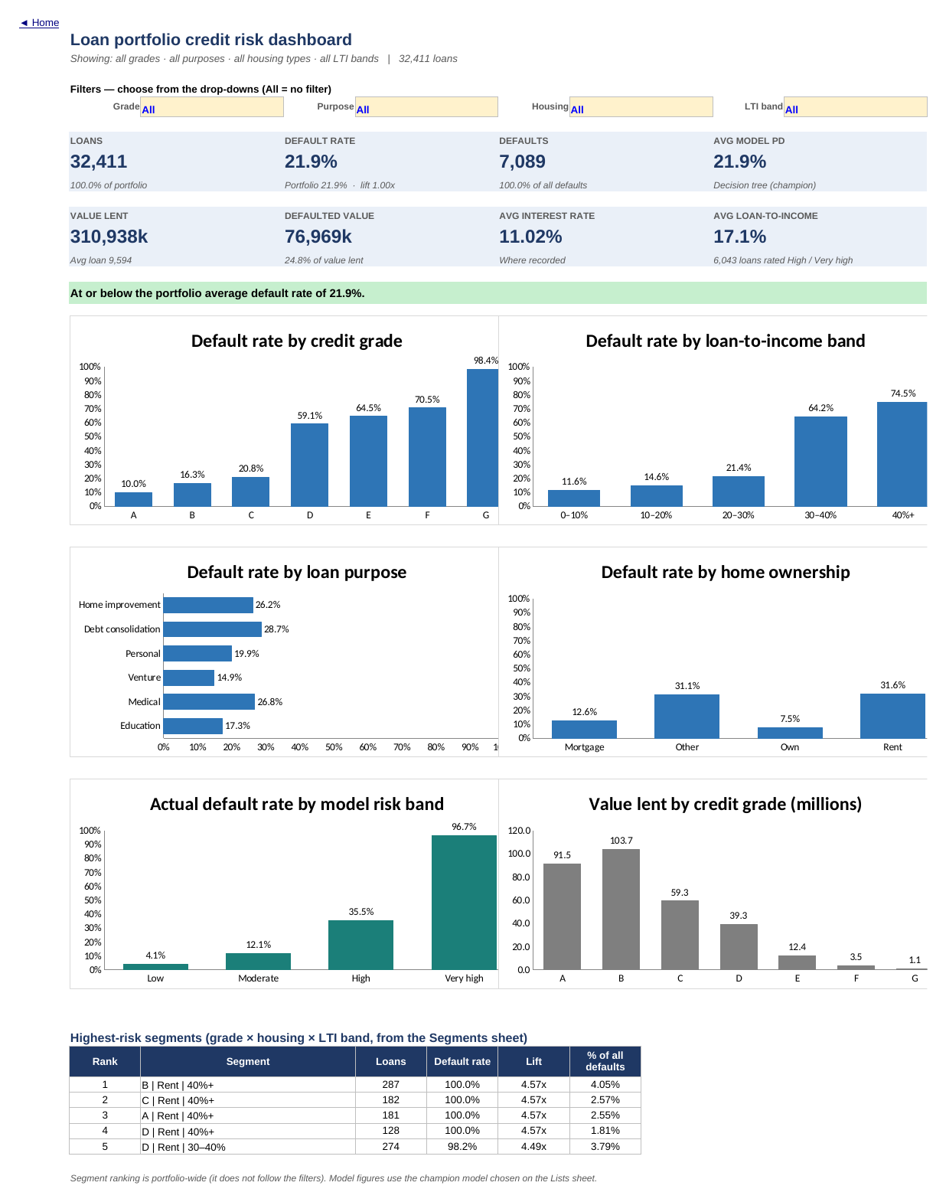
Figure 1. Dashboard (unfiltered view), exported from the workbook.
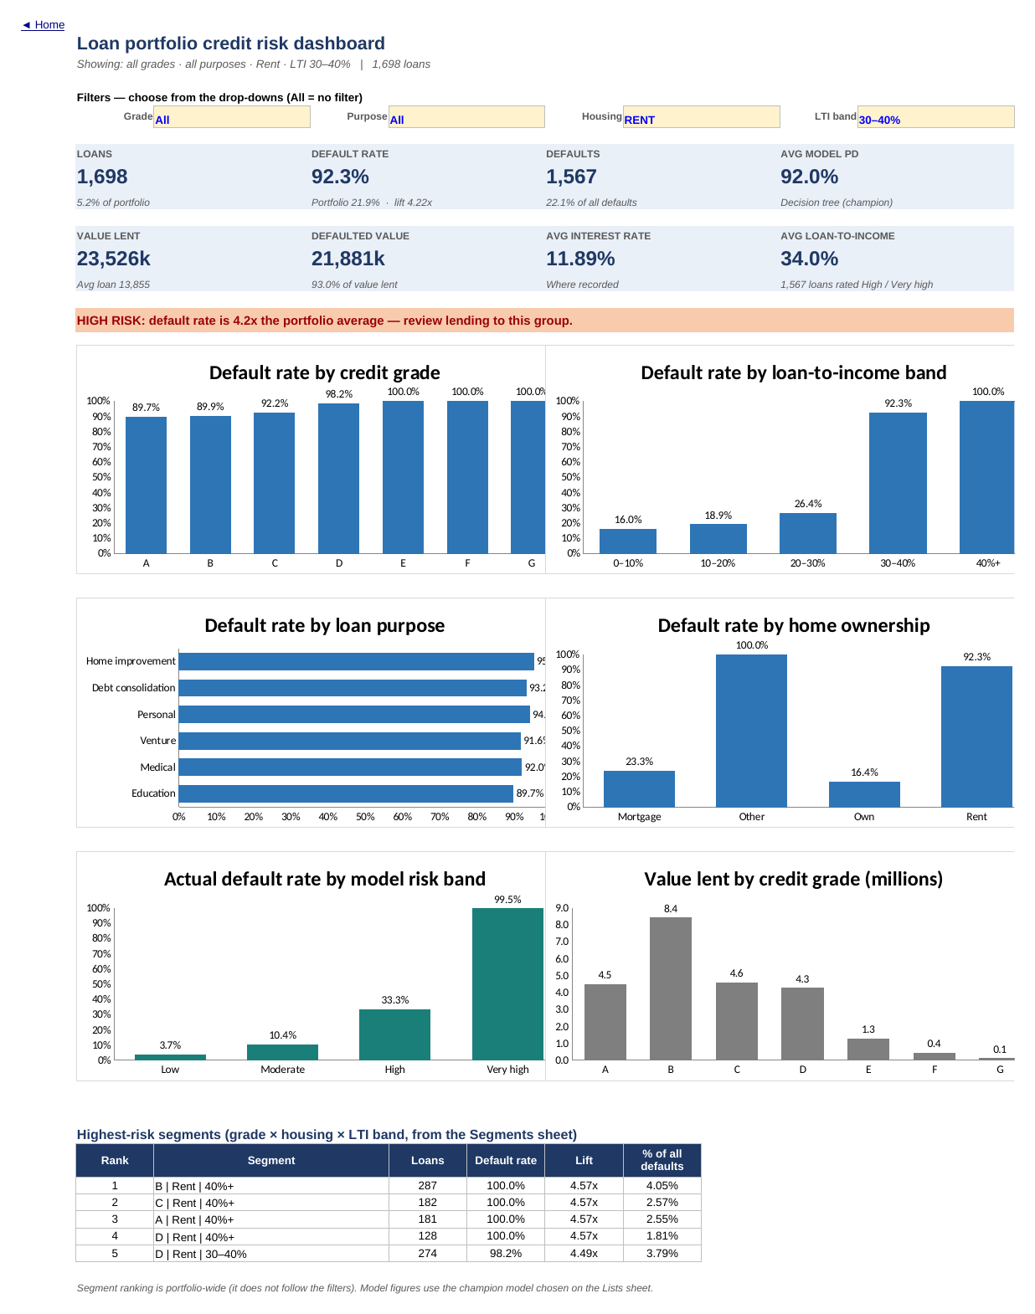
Figure 2. Dashboard filtered to renters with LTI 30–40%: the alert switches to HIGH RISK.

6.11 Applicant scorer, insights and QA
- Scorer: validated inputs (lists, numeric ranges, input-check message), derived inputs, both model PDs, the matching tree rule, champion PD, risk band, suggested action and the historical default rate of similar loans (same grade, housing and LTI band).
- Insights: ten findings whose evidence is a live sentence built with TEXT() and defined names, so the narrative updates with the data; plus monitoring indicators with current values.
- QA_Checks: 28 checks (record counts, exclusions, reconciliation of totals, split balance, leaf coverage, PD validity, MLE property, agreement with independent Python results, frozen-parameter governance), each with tolerance and PASS/FAIL, rolled up to a status shown on Home.

6.12 Supporting tools and why
Tool | Purpose | Why not Excel alone
pandas | Apply cleaning rules; create IDs, flags, bands and the stratified split | Reproducible, scripted rules; Power Query equivalent supplied (not run in the build environment)
statsmodels | Maximum-likelihood logistic regression; standard errors; likelihood-ratio test for variable selection | Excel has no logistic regression; Solver can confirm coefficients but not standard errors
scikit-learn | CART decision tree with 5-fold cross-validated tuning; gradient-boosting benchmark | Excel cannot grow a tree; the fitted tree is implemented as formulas

7. Objective-by-objective analysis

7.0 Direct answers to the business questions
Question | Answer
How many loans? | 32,411 after cleaning (32,581 in the raw file).
What % defaulted? | 21.9% (7,089 loans); 24.8% by value.
Total value issued? | 310,937,900 (currency not documented); 76,968,675 in loans that defaulted.
Distribution across grades? | A 33.0%, B 32.0%, C 19.9%, D 11.2%, E 3.0%, F 0.7%, G 0.2%.
Largest purposes by lending? | Fairly even: Education 19.5%, Medical 18.0%, Venture 17.5% of value lent; home improvement smallest (12.0%).
Highest-default grades? | G 98.4%, F 70.5%, E 64.5%, D 59.1%; A–C 10.0–20.8%.
Income and default? | Yes, strong and negative: under 25k 54.6% vs 120k+ 8.4%; Welch t on ln(income) = -50.0, Cohen’s d = -0.71.
Loan-to-income and default? | The strongest driver: 11.6% (<10%) → 21.4% (20–30%) → 64.2% (30–40%) → 74.5% (40%+); Cramér’s V 0.432.
Shorter employment? | Yes, modestly: under 1 yr 28.0% vs over 10 yrs 16.2%; unknown 31.7%; V 0.107 (small).
Purpose and home ownership? | Debt consolidation 28.7%, medical 26.8%, home improvement 26.2% highest; venture 14.9% lowest. Renters 31.6%, mortgage 12.6%, owners 7.5%.
Interest rate and default? | Yes overall (r = 0.336; 9.4% under 8% vs 68.8% at 18%+), but it mirrors grade and adds little within a grade.
Can PD be estimated? | Yes: both models score every loan; the tree’s Very-high band defaults at 96.7% and its Low band at 4.1%.
Most useful variables? | Loan-to-income, grade, housing and income; then purpose and employment-data availability. Age and credit-history length add nothing.
Logistic vs tree? | Tree better: test AUC 0.905 vs 0.880 (grade alone 0.728).
Share of defaults identified? | At a 50% threshold: tree 68.3%, logistic 57.5%. At the lowest-cost threshold (cost ratio 5): tree 74.1% with 4.1% of good loans flagged.

7.1 Objective 1 - Portfolio performance and risk profile
What it establishes: the size, outcome and concentration of the book. Data: loan amount, status, grade, purpose, housing. Procedure: headline KPIs and distribution tables (Portfolio sheet).
Grade | Loans | % loans | Value lent | % value | Avg rate % | Default rate
A | 10,703 | 33.0% | 91,464,650 | 29.4% | 7.33 | 10.0%
B | 10,384 | 32.0% | 103,742,875 | 33.4% | 11.00 | 16.3%
C | 6,436 | 19.9% | 59,343,250 | 19.1% | 13.47 | 20.8%
D | 3,620 | 11.2% | 39,297,850 | 12.6% | 15.37 | 59.1%
E | 963 | 3.0% | 12,441,875 | 4.0% | 17.02 | 64.5%
F | 241 | 0.7% | 3,546,875 | 1.1% | 18.61 | 70.5%
G | 64 | 0.2% | 1,100,525 | 0.4% | 20.25 | 98.4%

Purpose | Loans | % loans | Value lent | % value | Rank (value) | Default rate
Education | 6,409 | 19.8% | 60,750,200 | 19.5% | 1 | 17.3%
Medical | 6,042 | 18.6% | 56,018,875 | 18.0% | 2 | 26.8%
Venture | 5,680 | 17.5% | 54,421,500 | 17.5% | 3 | 14.9%
Personal | 5,497 | 17.0% | 52,664,100 | 16.9% | 4 | 19.9%
Debt consolidation | 5,189 | 16.0% | 49,841,750 | 16.0% | 5 | 28.7%
Home improvement | 3,594 | 11.1% | 37,241,475 | 12.0% | 6 | 26.2%
Interpretation: the book is concentrated in the better grades (A-C hold 84.9% of loans) and spread evenly across purposes, with education the largest by value. Renters take 50.5% of loans. Average loan 9,594; average LTI 17.1%; 12.8% of loans have LTI of 30% or more. Implication: a 21.9% default rate is high for any lender, and the value-weighted rate (24.8%) shows larger loans default more. Limitation: without dates, the trend cannot be assessed.

7.2 Objective 2 - Characteristics associated with default
Procedure: default-rate tables and chi-square tests for nine banded characteristics (Risk_Drivers), plus grade and rate (Grade_Rate); Welch t-tests for continuous measures.
Characteristic | χ² | df | p-value | Cramér’s V | Effect
Loan-to-income band | 6,048 | 4 | < 1e-300 | 0.432 | Medium
Loan grade | 5,587 | 6 | < 1e-300 | 0.415 | Medium
Interest-rate band | 4,149 | 7 | < 1e-300 | 0.358 | Medium
Income band | 2,942 | 5 | < 1e-300 | 0.301 | Medium
Home ownership | 1,895 | 3 | < 1e-300 | 0.242 | Small
Prior default on file | 1,043 | 1 | 9.9e-229 | 0.179 | Small
Loan purpose | 520 | 5 | 4.8e-110 | 0.127 | Small
Loan amount band | 445 | 4 | 5.2e-95 | 0.117 | Small
Employment length | 371 | 5 | 4.7e-78 | 0.107 | Small
Age band | 30 | 4 | 4.4e-6 | 0.031 | Negligible
Credit history length | 26 | 4 | 3.6e-5 | 0.028 | Negligible

Measure | Mean (default) | Mean (no default) | Welch t | Cohen’s d | r (pb)
ln(income) | 10.623 | 11.010 | -50.0 | -0.71 | -0.283
Loan-to-income | 0.249 | 0.149 | 60.2 | 1.01 | 0.386
Interest rate % | 13.07 | 10.44 | 57.8 | 0.86 | 0.336
Employment (yrs) | 4.12 | 4.97 | -15.8 | -0.21 | -0.086
Age | 27.47 | 27.80 | -3.9 | -0.05 | -0.022
Credit history (yrs) | 5.68 | 5.85 | -2.9 | -0.04 | -0.016
Interpretation: affordability dominates. LTI (V 0.432, d 1.01) and income (V 0.301) are the strongest borrower-level signals; housing is moderate (renters 31.6% vs owners 7.5%); purpose and employment length are weaker but real; unknown employment (31.7%) is riskier than any known band. Age and credit-history length are statistically significant only because n is large — the effects are negligible (V ≈ 0.03, d ≈ 0.05). A prior default doubles the default rate (37.9% vs 18.4%), but the flag appears only in grades C–G. Implication: affordability and housing should sit beside grade in credit policy. Limitation: associations, not causes; income and LTI are correlated, which the models handle jointly.
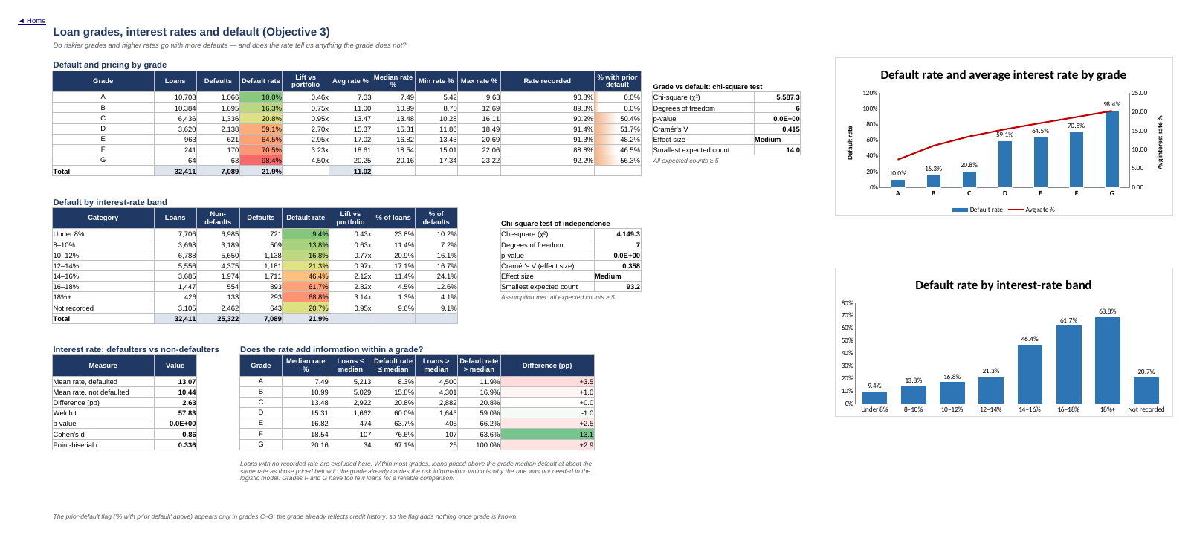
Figure 3. Grade_Rate sheet: default and pricing by grade, rate bands and the within-grade test.

7.3 Objective 3 - Loan grades, interest rates and default
Grade | Default rate | Avg rate % | Rate range % | % with prior default | Rate ≤ median: default | Rate > median: default
A | 10.0% | 7.33 | 5.42–9.63 | 0.0% | 8.3% | 11.9%
B | 16.3% | 11.00 | 8.70–12.69 | 0.0% | 15.8% | 16.9%
C | 20.8% | 13.47 | 10.28–16.11 | 50.4% | 20.8% | 20.8%
D | 59.1% | 15.37 | 11.86–18.49 | 51.7% | 60.0% | 59.0%
E | 64.5% | 17.02 | 13.43–20.69 | 48.2% | 63.7% | 66.2%
F | 70.5% | 18.61 | 15.01–22.06 | 46.5% | 76.6% | 63.6%
G | 98.4% | 20.25 | 17.34–23.22 | 56.3% | 97.1% | 100.0%
Interpretation: default rises monotonically with grade, with a sharp break between C (20.8%) and D (59.1%). Rates are priced by grade, so the overall rate–default relationship (Welch t = 57.8; default rate 9.4% under 8% vs 68.8% at 18%+) largely reflects grade. Within grades, loans priced above the median default at about the same rate as those below it (C: 20.8% vs 20.8%; D: 60.0% vs 59.0%); only grade A shows a modest gap (8.3% vs 11.9%), and F/G are too small to judge. The logistic model confirmed this: adding the rate to the grade changed test AUC by less than 0.001. Implication: pricing is not adding risk discrimination beyond the grade; grades D–G may be under-priced relative to 59–98% default rates. Limitation: 9.6% of rates are missing.

7.4 Objective 4 - High-risk loan segments
Procedure: heat maps and a 140-segment table (grade × housing × LTI band), ranked by default rate with a minimum size of 100 loans; segments at ≥ 50% default are flagged (both thresholds adjustable).
Rank | Segment (grade | housing | LTI) | Loans | Default rate | Lift | % of all defaults
1 | B | Rent | 40%+ | 287 | 100.0% | 4.57x | 4.05%
2 | C | Rent | 40%+ | 182 | 100.0% | 4.57x | 2.57%
3 | A | Rent | 40%+ | 181 | 100.0% | 4.57x | 2.55%
4 | D | Rent | 40%+ | 128 | 100.0% | 4.57x | 1.81%
5 | D | Rent | 30–40% | 274 | 98.2% | 4.49x | 3.79%
6 | C | Rent | 30–40% | 344 | 92.2% | 4.21x | 4.47%
7 | B | Rent | 30–40% | 615 | 89.9% | 4.11x | 7.80%
8 | A | Rent | 30–40% | 359 | 89.7% | 4.10x | 4.54%
9 | D | Rent | 20–30% | 534 | 70.2% | 3.21x | 5.29%
10 | E | Rent | 20–30% | 150 | 68.7% | 3.14x | 1.45%
Results: 16 segments are flagged; together they hold 4,919 loans (15.2% of the book), 55.0% of all defaults and default at 79.3%. The dominant pattern is renting combined with high LTI: renters with LTI ≥ 30% number 2,533 (7.8% of loans), default at 94.8% and account for 33.9% of all defaults, while non-renters at the same LTI default at 24.2%. Grade D–E renters are high-risk at every LTI. Implication: a simple, explainable rule targets a third of all defaults while touching under 8% of lending. Limitation: perfectly separated segments (100% default) are unusual in real data and suggest rule-generated outcomes.
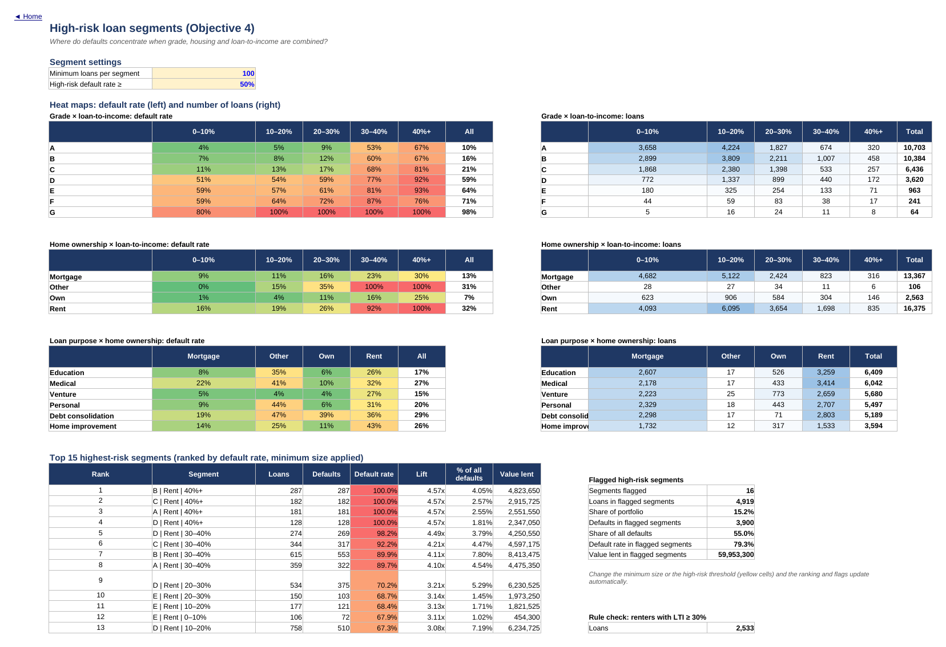
Figure 4. Segments sheet: heat maps and the ranked high-risk segments.

7.5 Objective 5 - Predicting default

Design
- Stratified 70/30 split (seed 42): 22,687 training and 9,724 test loans, both 21.87% default. Imputation values were frozen from the training rows only; the test set was used once, for evaluation.
- Logistic regression: candidates screened with a likelihood-ratio test; employment length, prior default, age, credit history and interest rate were dropped together (χ² = 10.5, df 5, p = 0.062). LTI² was added after a linearity check (test AUC 0.876 → 0.880). McFadden R² 0.373; train AUC 0.881 vs test 0.880 (no overfitting).
- Decision tree: depth capped at 6 for readability and Excel implementation; depth 6 / minimum leaf 50 chosen by 5-fold CV (AUC 0.902); 32 leaves; train AUC 0.906 vs test 0.905.

Key logistic results (odds ratios)
Effect | Odds ratio | Reading
Grade D vs A | 20.06 | Default odds 20× higher, other factors equal
Grade C vs A | 2.22 | The C→D step is far larger than A→C
Renter vs mortgage | 2.25 | More than double the odds
Owner vs mortgage | 0.15 | Odds cut by about 85%
Debt consolidation vs education | 2.26 | Highest-risk purpose
Venture vs education | 0.75 | Lowest-risk purpose
ln(income) +1 (≈ 2.7× income) | 0.30 | Higher income sharply lowers odds
Employment unknown | 1.91 | Missing data nearly doubles the odds
LTI, LTI² | — | Convex: modelled PD for a grade-B renter rises from 10.2% at 20% LTI to 51.6% at 40% and 86.4% at 50%

Test-set performance
Metric | Logistic | Tree | Grade D–G rule | No model
AUC (area under ROC curve) | 0.880 | 0.905 | 0.728 | 0.500
Gini (2 × AUC − 1) | 0.759 | 0.810 | 0.456 | 0.000
KS statistic (max TPR − FPR) | 0.625 | 0.701 | 0.357 | 0.000
Recall — share of defaults caught | 57.5% | 68.3% | 43.2% | 0.0%
Precision — flagged loans that defaulted | 77.5% | 96.4% | 61.6% | 0.0%
Specificity — good loans not flagged | 95.3% | 99.3% | 92.4% | 100.0%
Accuracy | 87.1% | 92.5% | 81.7% | 78.1%
F1 score | 0.660 | 0.799 | 0.508 | 0.000
Share of loans flagged | 16.2% | 15.5% | 15.4% | 0.0%
Threshold 50% unless stated. AUC is computed in Excel on a 101-point grid; exact (rank-based) values from scikit-learn are 0.880 and 0.905.
At a 50% threshold the tree flags 1,507 test loans and catches 1,452 of 2,127 defaults (68.3%) with only 55 false alarms; the logistic model catches 1,224 with 356 false alarms. With a cost ratio of 5:1, the lowest-cost thresholds are 0.18 for the tree (recall 74.1%, 4.1% of good loans flagged) and 0.23 for the logistic model (recall 78.4%, 16.4%). Ranked by the tree, the riskiest 24% of test loans contain 77% of defaults (logistic: 20% → 66%). Both models are reasonably calibrated; the logistic model over-predicts slightly in the 20–30% PD band (24.6% predicted vs 18.6% actual).
Why the tree wins: risk here is interactive — high LTI is far more dangerous for renters, and grade D–G renters with short employment default almost always — and a single tree captures these thresholds while a main-effects logistic model cannot. Which variables matter most: IV ranks LTI (0.906), grade (0.860), rate (0.662), income (0.506) and housing (0.381) highest; the tree’s importance is LTI 33%, grade 24%, renting 19%, income 9%, purpose 10%. Rate’s high IV disappears once grade is known. As a benchmark only, a gradient-boosted model in Python reached AUC 0.944 — more accurate but not transparent or maintainable in Excel. Limitation: validation is on a random hold-out from the same period; IV values above 0.5 would normally prompt a leakage review.
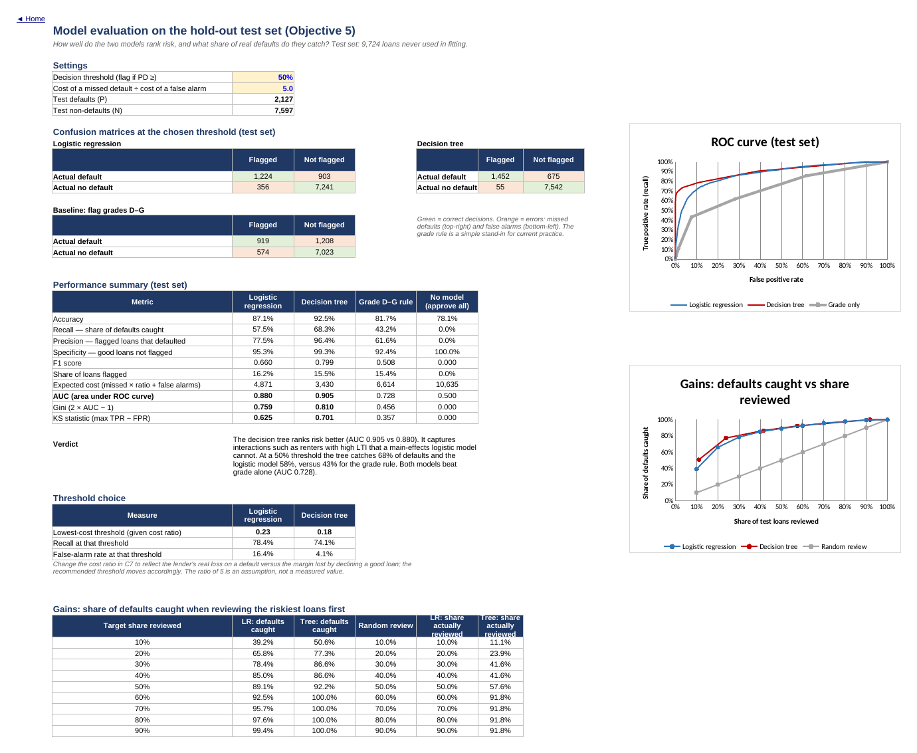
Figure 5. Model_Eval sheet: confusion matrices, performance summary, ROC and gains.

7.6 Objective 6 - Recommendations for credit-risk monitoring
Findings were translated into prioritised actions (Section 9) and a set of monitoring indicators with current values on the Insights sheet: portfolio default rate, share of lending at LTI ≥ 30%, share to renters at LTI ≥ 30%, share in grades D–G, share in flagged segments, share with unknown employment, champion-model AUC on new outcomes, and QA status.

7.7 Objective completion summary
Objective | Analytical procedure | Excel functionality | Result | Business interpretation
1 | KPIs; distributions by grade, purpose, housing, amount | COUNTIFS, SUMIFS, AVERAGEIFS, RANK.EQ, defined names, data bars | 32,411 loans; 21.9% default; 310,937,900 lent | High-risk book concentrated in A–C by count but with costly D–G tail
2 | Band tables; χ², Cramér’s V; Welch t; r | SUMPRODUCT, CHISQ.DIST.RT, T.DIST.2T, STDEV.P, array MEDIAN(IF) | LTI V 0.432, income 0.301, housing 0.242 | Affordability and housing drive risk; age irrelevant
3 | Grade table; rate bands; within-grade split | MINIFS/MAXIFS, COUNTIFS with "<="&median | C→D jump; rate adds ~nothing within grade | Grade carries the pricing signal; D–G pricing review
4 | Heat maps; 140-segment ranking | LARGE + INDEX/MATCH, colour scales, input thresholds | 16 segments, 55.0% of defaults | Renter + LTI ≥ 30% rule
5 | Logistic regression; decision tree; evaluation; IV | SUMIFS scoring, nested IF, ROC table, LARGE(IF), Solver-ready LL | AUC 0.880 / 0.905; recall 68.3% at 50% | Tree score as second-line check
6 | Findings → actions; KRIs | Live TEXT() narrative, defined names | 10 findings, 8 KRIs | Monitoring framework

8. Key findings
Finding | Evidence | Interpretation | Business implication | Recommended action
Loan-to-income is the strongest driver of default | Default 21.4% at 20–30% LTI vs 64.2% at 30–40% and 74.5% above 40%; Cramér’s V 0.432; IV 0.906; top tree split at ~30% | Likely explanation (not tested here): borrowers committing over 30% of income have little room to absorb shocks | Affordability does not appear to be controlled by the current grading | Introduce a 30% LTI review threshold
Renters with LTI ≥ 30% almost always default | 2,533 loans, 94.8% default, 33.9% of all defaults; non-renters at same LTI 24.2% | Housing changes how dangerous high LTI is (interaction) | One rule targets a third of defaults for under 8% of lending | Decline or restructure; monitor as a KRI
Grade risk jumps between C and D | C 20.8% vs D 59.1%; G 98.4%; D–G = 15.1% of loans | Grades D–G are a distinct high-risk tier | Pricing (15–20%) is unlikely to cover 59–98% default | Review D–G pricing, limits and grade boundaries
Interest rate adds little beyond grade | Within-grade above/below-median default rates nearly equal; LR AUC unchanged with rate | Rate appears to be set from grade | Pricing is not an independent risk control | Monitor grade, LTI and housing rather than rate
Unknown employment is a risk signal | 31.7% default vs 21.9% overall; odds ratio 1.91 in the logistic model | Incomplete applications may indicate weaker borrowers or weaker checks | Data gaps hide risk | Make employment a mandatory verified field
Default is highly predictable from application data | Tree AUC 0.905, logistic 0.880, grade 0.728 | A small set of application fields separates good from bad borrowers | Better targeting than grade alone | Pilot the tree score as a second-line check
Findings describe associations in historical, approved-only data; they are not causal claims.

9. Business recommendations
Priority | Recommendation | Supporting evidence | Assumptions / dependencies
Immediate | Set an LTI review threshold at 30%; above 40% require a lower amount or extra security | Default 21% → 64% across the 30% line | Thresholds should be confirmed on real recent data
Immediate | Make "renter + LTI ≥ 30%" a hard decline/restructure rule and a KRI | 94.8% default; 33.9% of defaults | Fair-lending review of using housing status
Immediate | Make employment length mandatory and verified | Unknown employment defaults at 31.7% | Process change in origination
Immediate | Adopt the dashboard and Insights KRIs in monthly risk reporting | Live, reconciled measures | Data refresh process (Power Query script provided)
Medium term | Pilot the decision-tree score as a second-line check; route High/Very-high applications to senior review | Very-high band 96.7% default; AUC 0.905 | Validate on recent applications before use; governance sign-off
Medium term | Agree the cost of a missed default vs a declined good loan; set the threshold accordingly | Lowest-cost threshold tool on Model_Eval | Needs loss and margin data from Finance
Medium term | Review pricing and limits for grades D–G; recalibrate grade boundaries | C→D jump; rate adds nothing within grade | Needs loss-given-default to price properly
Long term | Capture origination date, loan ID, balance at default, recoveries, written default definition; fix LTI calculation at source | Gaps listed in Section 10 | Systems change
Long term | Move to a governed modelling platform for more accurate models with monitoring (drift, stability) | Benchmark AUC 0.944 vs 0.905 | Model-risk governance capability

10. Technical and analytical limitations

Observed limitations (in the data)
- No identifiers, dates, loss amounts or currency; default definition and observation window undocumented.
- Missing interest rate (9.6%) and employment length (2.7%); 11 placeholder rates; 7 impossible values.
- 428 defaulted records with an inconsistent loan-to-income field — a sign the outcome or amounts may have been edited after the fact, or of how the data was generated.
- Near-deterministic segments (e.g. 100% default for some renter/LTI groups) suggest rule-generated data; real-world accuracy would be lower.

Methodological limitations
- Random hold-out validation only; no out-of-time or out-of-population test.
- Logistic model has main effects only (plus LTI²); interactions are left to the tree.
- Tree PDs are coarse (32 distinct values); ties affect gains and threshold granularity.
- Median imputation for tree inputs; frozen at fit time.
- AUC in Excel is a 101-point trapezoid approximation (differs from exact by < 0.001).
- Chi-square p-values are uninformative at this sample size; effect sizes are used instead.

Contextual limitations
- Only approved loans — no information on rejected applicants (no reject inference); models may not generalise to the full applicant population.
- No macroeconomic context, product terms, collateral, or repayment history.
- Cost of errors unknown; the 5:1 cost ratio is an assumption for illustration.

Assumptions
- loan_status = 1 means default; grade A is the lowest-risk grade; cb_ fields come from a credit bureau; all amounts share one currency; fields are as at application.
- Exact duplicates are duplicated records, not distinct identical loans.

Additional data that would most improve the analysis
Data | Why
Origination and default dates | Trend, vintage and seasonality analysis; out-of-time validation
Loan ID and borrower ID | Deduplication certainty; repeat-borrower behaviour
Balance at default, recoveries, term | Loss given default, exposure at default and expected loss; pricing review
Declined applications | Reject inference and fair evaluation of new rules
Written default definition | Consistent KPI definition and model target

11. Validation and quality assurance

11.1 Data validation
- Raw (32,581) = cleaned (32,411) + excluded (170); exclusions listed record by record.
- Duplicate and invalid-value counts confirmed independently; missing-value categories reconcile (889 unknown employment, 3,105 unrecorded rates).
- Grade, purpose, LTI and segment tables reconcile to portfolio totals; train + test = all loans with identical default rates.

11.2 Analysis validation
Every headline KPI, all eleven chi-square statistics and Cramér’s V values, all eight Welch t-statistics and point-biserial correlations, the seven band assignments for every loan, all 32,411 logistic PDs (max difference < 1e-9), all tree-leaf assignments and PDs, AUCs, recall, precision, gains and segment flags were reconciled against independent calculations in pandas, SciPy, statsmodels and scikit-learn. All matched.

11.3 Deliverable validation — what was and was not tested
Item | Status
Workbook formulas | All 620,601 formulas recalculated in LibreOffice Calc 24.2 with zero errors; the delivered file re-opened and recalculated cleanly. The workbook was not opened in Microsoft Excel in the build environment.
Excel compatibility measures | Excel-2010+ function names prefixed correctly; no XLOOKUP or spilling functions; table column names and calculated-column formulas set explicitly; workbook flagged to recalculate fully on open
QA_Checks sheet | 28 / 28 checks PASS
Charts and layout | Reviewed visually from LibreOffice exports; rendering in Excel may differ slightly
Power Query script | Written to mirror the pandas rules; not executed (no Excel in the build environment)
Python script | Executed end to end; regenerates the processed data and model parameters
Report and README | Figures generated from the recalculated workbook

11.4 QA checklist
# | Check | Status
1 | Raw records in Data_Raw | PASS
2 | Cleaned + excluded records = raw records | PASS
3 | Duplicate records excluded | PASS
4 | Invalid-age records excluded | PASS
5 | Loan IDs strictly increasing (so no duplicates) | PASS
6 | No blank grades, purposes, housing or outcomes | PASS
7 | Missing employment length = Unknown band | PASS
8 | Missing interest rate = Not recorded band | PASS
9 | No ages above 100 remain | PASS
10 | Defaults (cleaned) | PASS
11 | Total value lent (cleaned) | PASS
12 | Grade table loans reconcile to portfolio | PASS
13 | Grade table value reconciles to portfolio | PASS
14 | Purpose table defaults reconcile | PASS
15 | LTI band loans reconcile | PASS
16 | Segment table covers every loan | PASS
17 | LTI mismatch flags (all on defaults) | PASS
18 | Train + test = all loans | PASS
19 | Train default rate ≈ test default rate (stratified split) | PASS
20 | Every loan routed to a tree leaf | PASS
21 | Logistic PDs all between 0 and 1 | PASS
22 | Logistic: mean predicted PD = actual rate on train (MLE property) | PASS
23 | Logistic log-likelihood matches statsmodels | PASS
24 | Logistic test AUC matches scikit-learn (grid approximation) | PASS
25 | Tree test AUC matches scikit-learn (grid approximation) | PASS
26 | Confusion matrices sum to test loans | PASS
27 | Frozen employment imputation = live training median | PASS
28 | Frozen rate imputation = live training medians (sum of 7 grades) | PASS
Recommended first step after download: open the workbook in Excel, confirm the Home sheet shows "ALL PASS", and try the dashboard filters.

12. Lessons and professional competencies demonstrated
Competency | Where it is demonstrated
Business problem framing | Problem statement, objective-to-analysis mapping, decisions supported (Sections 1–2)
Data quality and preparation | Systematic assessment; duplicate-block detection; LTI integrity investigation and sensitivity check; full cleaning log and record reconciliation
Advanced Excel | Structured tables and calculated columns; COUNTIFS/SUMIFS/AVERAGEIFS/MINIFS/MAXIFS; INDEX/MATCH; array formulas; SUMPRODUCT statistics; data validation; conditional formatting; defined names; charts; Solver-ready model
Statistical reasoning | Chi-square with effect sizes, Welch t-tests, assumption checks, within-grade confounding test, linearity check, likelihood-ratio variable selection
Predictive modelling and validation | Train/test design, cross-validated tuning, baseline comparison, ROC/AUC, KS, calibration, gains, cost-based threshold
Credit-risk domain knowledge | PD, risk bands, WoE/IV, Gini, grade calibration, affordability (LTI), reject-inference and loss limitations
Tool design and usability | Interactive dashboard, applicant scorer, input validation, settings sheet, QA sheet, documentation inside the workbook
Communication | Live findings, prioritised recommendations, README for non-technical readers
Professional integrity | Transparent disclosure of supporting tools, untested components, data provenance and limitations

Lessons
- The biggest insight came from an interaction (housing × LTI), not a single variable — always look at combinations once main effects are known.
- A strong univariate signal (interest rate, IV 0.66) can be redundant; testing within strata prevents over-claiming.
- Data-integrity anomalies concentrated in one outcome class deserve investigation before modelling — they can inflate apparent accuracy.
- Transparency has a price: the Excel-native tree trails a gradient-boosted benchmark by about 0.04 AUC, a trade-off worth stating explicitly to stakeholders.

13. Conclusion
The project met all six objectives. It established that 21.9% of 32,411 loans defaulted, showed that loan-to-income, grade, income and housing drive that risk while age and credit history do not, demonstrated that interest rate adds little beyond grade, and located a small set of segments - led by renters borrowing 30% or more of income - that account for over half of all defaults. Two transparent models estimate default probability for every loan; the decision tree (AUC 0.905) clearly outperforms both the logistic regression (0.880) and the existing grade (0.728).
These results are delivered as a working Excel tool rather than a static report: management can monitor any part of the book, adjust risk thresholds, compare models, score new applications and check data quality in one place. The recommendations include the data improvements needed before the models are used for real lending decisions.

Appendix A. Logistic regression coefficients
Variable | Level | Coefficient | Std error | z | p-value | Odds ratio
(intercept) | — | 9.4018 | 0.5194 | 18.10 | < 0.0001 | 1.21e+4
loan_grade | A | 0.0000 | ref. |  |  | 1.000
loan_grade | B | 0.3928 | 0.0591 | 6.65 | < 0.0001 | 1.481
loan_grade | C | 0.7974 | 0.0631 | 12.64 | < 0.0001 | 2.220
loan_grade | D | 2.9986 | 0.0689 | 43.53 | < 0.0001 | 20.057
loan_grade | E | 3.3149 | 0.1086 | 30.52 | < 0.0001 | 27.519
loan_grade | F | 3.8462 | 0.2122 | 18.12 | < 0.0001 | 46.817
loan_grade | G | 7.2419 | 1.0627 | 6.81 | < 0.0001 | 1.40e+3
person_home_ownership | MORTGAGE | 0.0000 | ref. |  |  | 1.000
person_home_ownership | OTHER | 0.6639 | 0.3542 | 1.87 | 0.0609 | 1.942
person_home_ownership | OWN | -1.9086 | 0.1269 | -15.04 | < 0.0001 | 0.148
person_home_ownership | RENT | 0.8128 | 0.0486 | 16.73 | < 0.0001 | 2.254
loan_intent | EDUCATION | 0.0000 | ref. |  |  | 1.000
loan_intent | DEBTCONSOLIDATION | 0.8161 | 0.0692 | 11.79 | < 0.0001 | 2.262
loan_intent | HOMEIMPROVEMENT | 0.9439 | 0.0790 | 11.94 | < 0.0001 | 2.570
loan_intent | MEDICAL | 0.6206 | 0.0674 | 9.21 | < 0.0001 | 1.860
loan_intent | PERSONAL | 0.1424 | 0.0726 | 1.96 | 0.0497 | 1.153
loan_intent | VENTURE | -0.2852 | 0.0763 | -3.74 | 0.0002 | 0.752
lti | — | -2.1519 | 0.7501 | -2.87 | 0.0041 | 0.116
lti_squared | — | 22.2130 | 1.6026 | 13.86 | < 0.0001 | 4.44e+9
ln_income | — | -1.2126 | 0.0460 | -26.37 | < 0.0001 | 0.297
emp_unknown | — | 0.6473 | 0.1200 | 5.40 | < 0.0001 | 1.910
Training n = 22,687; log-likelihood -7469.7; McFadden R² 0.373. Odds ratios for LTI and LTI² are per unit of LTI (i.e. per 100% of income) and are not meaningful individually; read them through the PD-by-LTI table on Model_LR.

Appendix B. Decision tree rules
Leaf | Rule | Train loans | Train default | Leaf PD | Test loans | Test default
L01 | LTI ≤ 15.5%; Grade A–C; Income ≤ 19,996; Rate ≤ 10.83%; Age ≤ 27.5 | 51 | 5.9% | 7.5% | 20 | 15.0%
L02 | LTI ≤ 15.5%; Grade A–C; Income ≤ 19,996; Rate > 10.83%; Age ≤ 27.5 | 50 | 14.0% | 15.4% | 28 | 21.4%
L03 | LTI ≤ 15.5%; Grade A–C; Income ≤ 19,996; Age > 27.5 | 54 | 31.5% | 32.1% | 24 | 25.0%
L04 | LTI 15.5%–30.4%; Grade A–C; Income ≤ 19,996 | 255 | 100.0% | 99.6% | 111 | 100.0%
L05 | LTI ≤ 30.4%; Grade A–C; Income 19,996–33,918; Purpose not Home improvement | 1,949 | 11.0% | 11.0% | 790 | 9.9%
L06 | LTI ≤ 30.4%; Grade A–C; Income 33,918–34,048; Purpose not Home improvement | 110 | 39.1% | 39.3% | 39 | 28.2%
L07 | LTI ≤ 30.4%; Grade A–C; Income 19,996–34,048; Home not Rent; Purpose: Home improvement | 90 | 23.3% | 23.9% | 42 | 16.7%
L08 | LTI ≤ 30.4%; Grade A–C; Income 19,996–34,048; Home: Rent; Purpose: Home improvement | 56 | 100.0% | 98.3% | 26 | 100.0%
L09 | LTI ≤ 30.4%; Grade A–C; Income > 34,048; Purpose not Venture; Rate ≤ 11.18% | 7,752 | 4.8% | 4.8% | 3,330 | 5.0%
L10 | LTI ≤ 30.4%; Grade A–C; Income > 34,048; Purpose: Venture; Rate ≤ 11.18% | 1,703 | 0.0% | 0.1% | 705 | 0.0%
L11 | LTI ≤ 30.4%; Grade A–C; Income 34,048–79,994; Rate > 11.18% | 3,440 | 11.0% | 11.1% | 1,473 | 10.8%
L12 | LTI ≤ 30.4%; Grade A–C; Income > 79,994; Rate > 11.18% | 1,640 | 5.0% | 5.1% | 741 | 5.3%
L13 | LTI ≤ 30.4%; Grade E–G; Home not Rent; Purpose not Medical/Education; Employment ≤ 2.5 yrs | 219 | 32.4% | 32.6% | 92 | 35.9%
L14 | LTI ≤ 30.4%; Grade E–G; Home not Rent; Purpose: Education; Employment ≤ 2.5 yrs | 77 | 13.0% | 13.9% | 35 | 20.0%
L15 | LTI ≤ 30.4%; Grade E–G; Home not Rent; Purpose: Medical; Employment ≤ 2.5 yrs | 54 | 88.9% | 87.5% | 20 | 80.0%
L16 | LTI ≤ 30.4%; Grade E–G; Home: Rent; Employment ≤ 2.5 yrs | 671 | 100.0% | 99.9% | 288 | 100.0%
L17 | LTI ≤ 30.4%; Grade E–G; Income ≤ 34,900; Purpose not Debt consolidation/Medical; Employment > 2.5 yrs | 128 | 45.3% | 45.4% | 74 | 44.6%
L18 | LTI ≤ 30.4%; Grade E–G; Income > 34,900; Purpose not Debt consolidation/Medical; Employment > 2.5 yrs | 1,063 | 17.2% | 17.3% | 434 | 15.9%
L19 | LTI ≤ 30.4%; Grade E–G; Home not Mortgage; Purpose: Medical; Employment > 2.5 yrs | 212 | 77.4% | 77.1% | 91 | 74.7%
L20 | LTI ≤ 30.4%; Grade E–G; Home: Mortgage; Purpose: Medical; Employment > 2.5 yrs | 109 | 100.0% | 99.1% | 61 | 100.0%
L21 | LTI ≤ 30.4%; Grade E–G; Home not Mortgage; Purpose: Debt consolidation; Employment > 2.5 yrs; Rate ≤ 15.08% | 51 | 76.5% | 75.5% | 19 | 89.5%
L22 | LTI ≤ 30.4%; Grade E–G; Home not Mortgage; Purpose: Debt consolidation; Employment > 2.5 yrs; Rate > 15.08% | 105 | 90.5% | 89.7% | 50 | 96.0%
L23 | LTI ≤ 30.4%; Grade E–G; Home: Mortgage; Purpose: Debt consolidation; Employment > 2.5 yrs | 140 | 100.0% | 99.3% | 58 | 100.0%
L24 | LTI > 30.4%; Income ≤ 19,900; Home not Rent | 63 | 100.0% | 98.5% | 23 | 100.0%
L25 | LTI > 30.4%; Grade A–B; Income > 19,900; Home not Rent/Own | 467 | 12.0% | 12.2% | 187 | 13.4%
L26 | LTI > 30.4%; Grade D–C; Income > 19,900; Home not Rent/Own | 114 | 29.8% | 30.2% | 66 | 25.8%
L27 | LTI > 30.4%; Grade A–C; Income > 19,900; Home: Own | 209 | 0.0% | 0.5% | 92 | 0.0%
L28 | LTI > 30.4%; Grade E–G; Income > 19,900; Home not Rent; Purpose not Medical; Age ≤ 24.5 | 61 | 57.4% | 57.1% | 25 | 32.0%
L29 | LTI > 30.4%; Grade E–G; Income > 19,900; Home not Rent; Purpose not Medical; Age > 24.5 | 86 | 38.4% | 38.6% | 45 | 37.8%
L30 | LTI > 30.4%; Grade E–G; Income > 19,900; Home not Rent; Purpose: Medical | 50 | 96.0% | 94.2% | 23 | 78.3%
L31 | LTI 30.4%–30.8%; Home: Rent | 55 | 89.1% | 87.7% | 34 | 94.1%
L32 | LTI > 30.8%; Home: Rent | 1,603 | 100.0% | 99.9% | 678 | 100.0%

